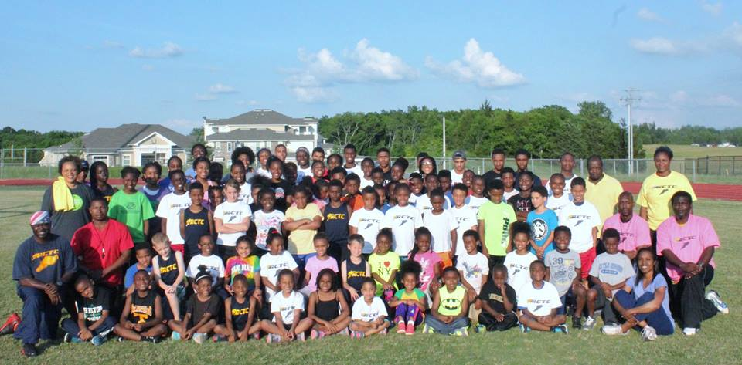

Rutherford County Track Club (“RCTC”) closed out another fantastic outdoor season by attending the AAU Junior Olympics in Norfolk VA., August 3 – August 8, 2015. This outdoor season the team consisted of 78 athletes and had 39 athletes compete in 58 individual events and 5 relays at the JO meet setting 31 personal records (“PR”). The individuals or relay team that finishes in the top 8 for their event receive a medal and are recognized as an All American in that event. RCTC was able to earn 6 top eight finishes this year.

The team got the week started on Monday, August 3rd by having 5 personal records, 2 individuals qualify for the semi-finals in their event and 1 individual qualify for the finals in their event: Mikah Charley 200M Hurdles, 28.96PR finished 15th, Lauren Bass 800M 2:33.53PR, finished 55th, Gerald Williams 100M 15.89PR, finished 77th, Jarvarian Otey 100M 13.85 PR, qualifying for semi-finals, John Sherman 100M 13.08 qualifying for semi-finals, Mikah Bailey 800M 1:58.54PR, qualifying for the finals, Jordan Hill 800M 2:00, finished 16th, Jaiden Battle 100M 15.12, finished 41st, Kynnedy Gilbert 100M 13.73, finished 25th, and Trenton Brewington 400M Hurdles, 59.28 finished 39th.

Tuesday, August 4th was the busiest day of the week as we had 2 All Americans, 13 personal records and 2 athletes qualify for the semi-finals in their event: Mikah Bailey 1500M 4:14.49PR, finishing 4th All American, Jorden Barnes 400M 59.35PR, finished 2nd All American, Jordan Hill 1500M 4:20.20PR, finished 16th, Gerald Williams 200M 33.83PR, finished 92nd and 400M 1:15.04PR, finished 41^{st,} , Jonathan Charley 400M 1:08.59PR , finished 24th , Damien Charley mini-javelin 62.06 feet PR, finished 40th, Keasyia Ward 200M 26.99PR, finished 75th , Jaiden Battle 200M 32.03PR, finished 69th and 400M 1:17.46 finished 61st, Taylah Upshaw 200M 31.53PR, finished 61st, and 400M 1:11.87, finished 27th, Cyera Gordon long jump 17-7.5 feet PR, finished 10th and 200M 25.81, finished 62nd , Javarion Otey 200M 28.83, qualified for semi-finals, Kynnedy Gilbert 200M 27.28PR, qualified for semi-finals and 400M 1:03.90PR, finished 17th, McKenzie Louis 400M 1:04.90, finished 52nd, Malachi Gordon 400M 1:25.13, finished 99th, Haran Bass 400M 1:19.70, finished 84th, and Kalissa Marion 1500M 5:44, finished 47th.

Wednesday, August 5th, the team had another All-American performance, 2 qualified for the finals in their event and 7 personal records: Mikah Bailey 800M 1:57.57PR, finishes 4th All American, Roland McGhee 80M Hurdles 13.43PR, qualifies for the finals, Javen Otey 100M 13.68PR, qualifies for the finals, Quinten Bowden 800M 2:43.96PR, finished 57th, Trenton Brewington 110M Hurdles 15.12PR, finished 42nd, Kyleigh King 800M 3:00.28PR, finished 77^{th,} Boys 11 – 12 year old 4 x 400M Relay (Tahmar Upshaw, Sean Williams, Damien Charley and Jorden Barnes) 4:31.22PR, finished 21^{st,} John Sherman 100M 13.24, finishes 21st, Tahmar Upshaw 800M 2:42.03, finished 58th, Darius Butler shot put 23.9 feet, finished 58th, McKenzie Louis 800M 2:38.12, finished 36th, Mikah Charley 100M Hurdles 16.04, finished 17th, and Kalea Barnett shot put 36-05.75 feet, finished 17th,.

Thursday, August 6th, the athletes are excited as the week is close to the end and it is beach day after a short competition day. The team had another All American performance and recorded 3 more personal records: Roland McGhee 80M hurdles 13.84, finished 7th All American, Kyleigh King 1500M 6:09.13PR, finishes 55th, Girls 13 – 14 year old 4 x 400M Relay (Cameron Robinson, Mikah Charley, Kennedy Spicer and Keasyia Ward) 4:27.24PR, finished 49th, Girls 15 – 16 year old 4 x 400M Relay (Dymanique Thompson, Annia Johnson, Lauren Bass and Cyera Gordon) 4:09.97PR, finished 33rd, Kynnedy Gilbert 200M semi-finals 27.69, finishes 14th, Javarian Otey 200M semi-finals 29.01, finished 15th, Darius Butler discus 68.06 feet, finished 24th,McKenzie Louis 1500M 5:43.31, finishes 49th, Kennedy Spicer long jump 14-10 feet, finishes 25th, Mikah Charley long jump 15-5 feet, finishes 16th, and Vaughn Marion mini-javelin 66.04 feet, finished 16th .

Friday, August 7th, the team had another All American performance and 2 personal records: Roland McGhee long jump 15-09.75PR feet, finished 8th All American, , Boys 11 – 12 year old 4 x 100M Relay (Roland McGhee, John Sherman, Sean Williams and Kali Riggins) 52.49PR, finished 17th, Sania McGhee mini-javelin 22-00 feet, finished 56th, Keasyia Ward 400M 1:07.68, finished 89th, Boys 9 – 10 year old 4 x 100M Relay (Vaughn Marion, Jonathan Charley, Jabari Gordon and Javarian Otey) 1:00.52, finished 31st, and Mikah Bailey 400M 52.37, finished 48th

Saturday, August 8th, this is the last day of competition for the week and we have 3 athletes competing and the team had an All American performance and 1 personal record for the day: Javarian Otey 100M 14.05, finished 7th All American, Colin King mini-javelin 40-05PR feet, finished 40th, and Quinten Bowden mini-javelin 51-02 feet, finished 51st .

What an amazing week of competition and family atmosphere we had that week. Rutherford County Track Club is a local, 501 (C) 3, track club that has been in existence for 8 years that trains athletes from the age of 7 – 18 in track and field. The club currently practices at Smyrna High School for its indoor and outdoor seasons. For further information about the track club including contact information please visit our website www.rctrackclub.org . Also like us on Facebook.

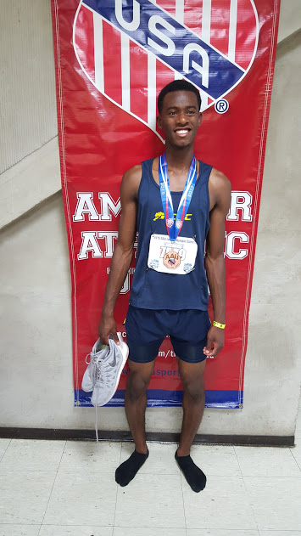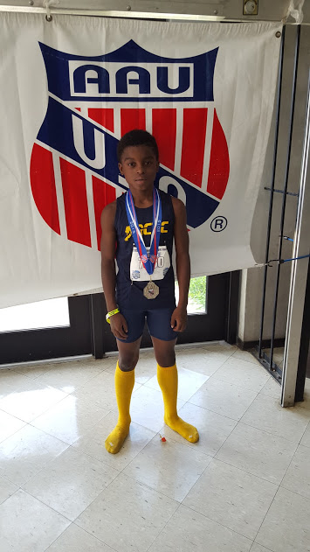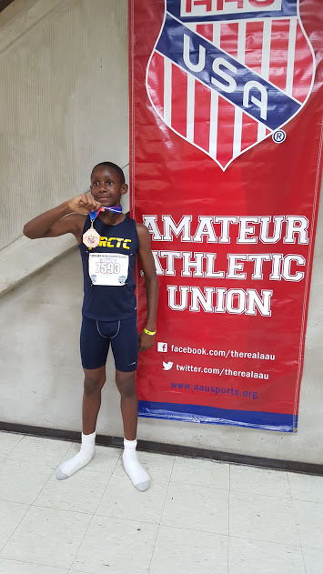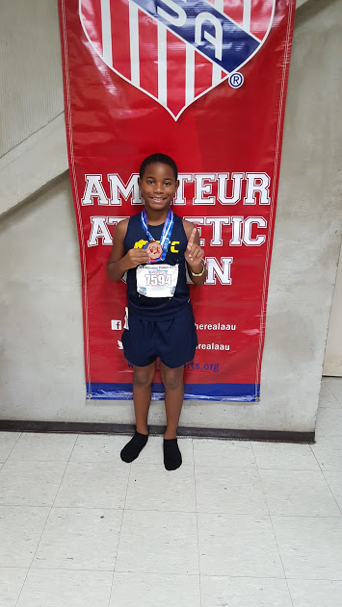

Mikah Bailey Jorden Barnes Roland McGhee Javarian Otey
4th 1500M 2nd 400M 7th 80M Hurdles 7th 100M
4th 800M 8th Long Jump

